WEB APPLICATION SECURITY
For security Testing we install DVWA in Kali Linux,
- SQL Injection
Attack Scenario: Attacker insert a command at a log in page in the place of user id of any website, their command is like ‘ OR ‘ 1’=’1 .
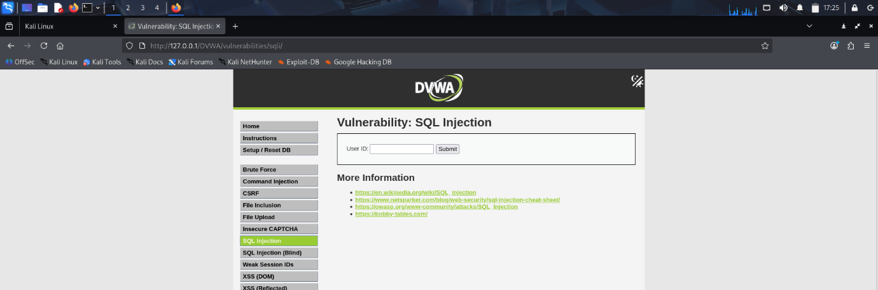
Mitigation: To prevent cyber security threads and vulnerability one should follow the step of mitigation which has been listed down below;
- Use Prepared Statements
- Validate & Sanitize user input
- Use Stored Procedures
- Escape special characters
- Apply Least Privilege for DB users
- Use Web Application Firewall (WAF)
- In DVWA High Level = SQLi Protected

- Cross-Site Scripting(XSS)
  - Stored XSS
Attack Scenario: Attacker submits a malicious payload into a persistent input (e.g., comment, profile bio) & in DVWA attacker put any unknown name and attacking command like
<script>alert(1)</script>
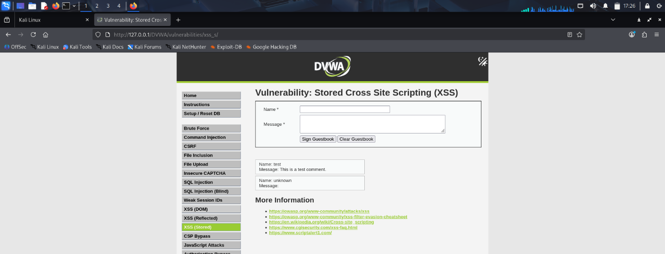
Mitigation:
- Output-encode user data before rendering in HTML (escape & < > " ' /).
- Sanitize input server-side (use a tested library — do not write ad-hoc regexes).
- Use CSP (Content-Security-Policy) to block inline scripts and restrict script sources.
- Set cookies Http Only, Secure, Same Site to reduce cookie theft.
- Avoid dangerous APIs: don’t inner HTML untrusted content; prefer text Content or templating engines that auto-escape.
  - Reflected XSS
Attack Scenario: Attacker crafts a URL containing a malicious payload in a parameter (e.g., ?q=<script>alert(1)</script>). And in DVWA attacker give command at user name
<script>alert(1)</script>
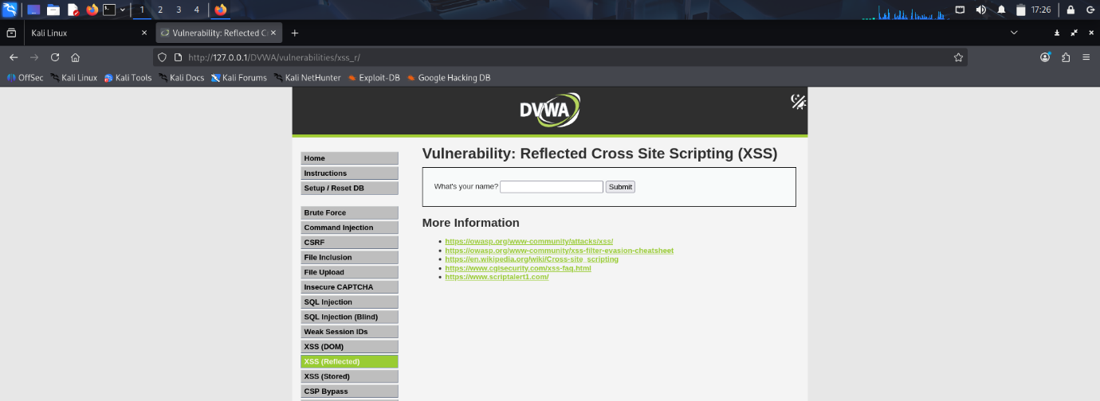
Mitigation:
- Output-encode any untrusted value before inserting into HTML, HTML attributes, JavaScript, or URL contexts (context-aware escaping).
- Validate & normalize inputs server-side — whitelist formats where possible.
- Do not reflect raw user input back into responses; prefer server-side lookups or safe placeholders.
- Use frameworks/templating that auto-escape (handle different contexts).
  - Content Security Policy
Add a browser rule that restricts which scripts or resources can run. It helps reduce XSS impact even if malicious code is injected.
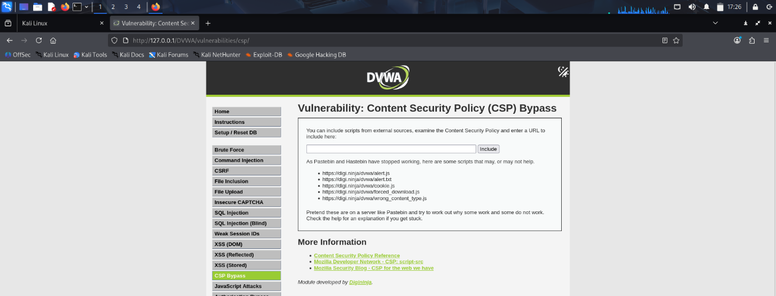

Mitigation: Prevent malicious input (like <script> tags) from being stored or reflected in the web page.
Steps in DVWA:
- Validate and sanitize all user inputs in forms (comments, search, etc.).
- Use whitelisting — accept only allowed characters or formats.
- Encode output before displaying to avoid script execution.

- Cross-Site Request Forgery (CSRF)
Attack Scenario: Attacker change their password and copy the URL and send or put that URL in same placer were any person click and their password get change and attacker access their account.
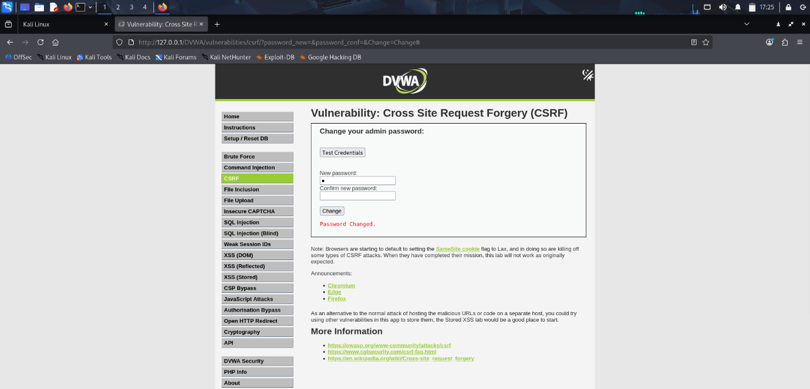
Mitigation:
- DVWA adds a unique random token ( user_token ) in each form.
- The token is stored in the user session.
- Server can verify the Referer header to ensure the request came from the same origin (DVWA site).
- Before critical actions (like password changes), DVWA may require re-login to confirm legitimacy.

